**Bluetooth interface- smart phone controlled light system**

**Circuit Diagram**:

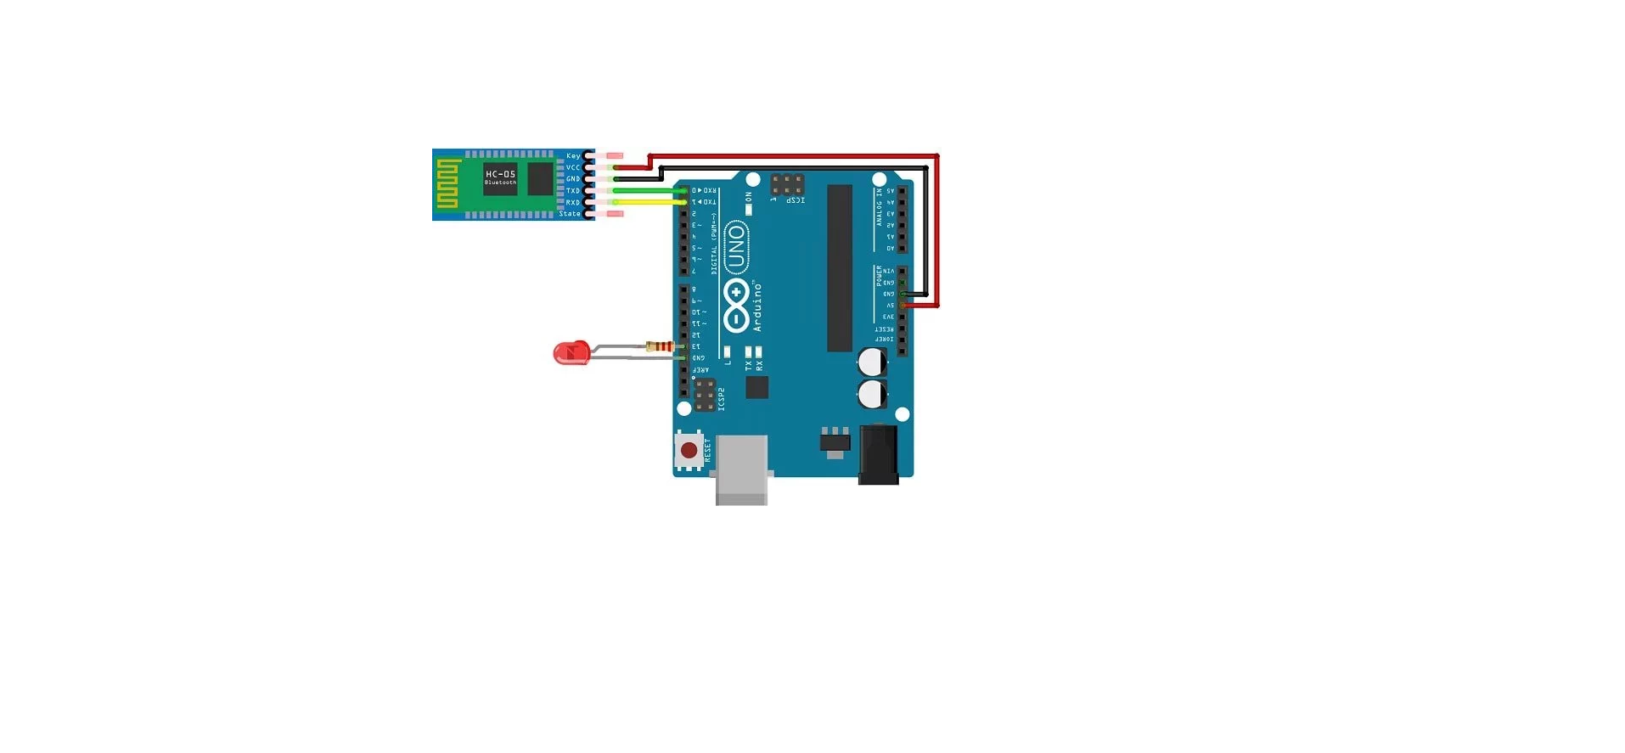

**Theory:**

Concepts Used:

1. using of blue tooth module.
2. Connecting phone with arduino.

**Learning & Observations**:

Learned the working of bluetooth module.Understood the use of bluetooth module.

We can make many useful devices using bluetooth.

**Problems & Troubleshooting**

Unknowingly the connections were made wrong.

There was a problem when uploading the code.

Understood the problem and firstly uploaded the code and then made the connections.

**Precautions**

1. Check the LED,bluetooth and Arduino are working properly.
2. Declare pins used .
3. Make the connections of bluetooth module after uploading the code.
4. Make the connections of bluetooth module properly.

**Learning Outcomes**

Learned the working and use of bluetooth module and it was really fun . Things I learned will be very useful.